Student Profile Management System

Project Documentation
Date: 04/19/2026

Group Member: Prasan Manandhar, Saksham Poudel, Shitansha Baral, Subigya Ghimire

INTRODUCTION

Student Profile Management System is Python-based application which is designed to manage and organize student information accurately. Application system allows different kind of users such as administrator and student allowing to interact with the platforms according to their roles. The main objective of this project is to demonstrate the use of modular programming, role-based user control, as well as basic user authentication in a structured software system.

OBJECTIVE

The main objective of this system is to design a simple and functional management system for student profile. This system allows to authenticate user login system as well as it helps to differentiate system according to the user’s role. This project applies modular programming concept of python and a user-friendly command line interface.

SYSTEM OVERVIEW

This application function through a main entry file that is main.py, which helps to control the overall application flow. This file connects different modules which are responsible for authentication, administrative task and student functionalities.

KEY FEATURES

The main feature of this system is it has user login system, role-based menu access, admin panel for managing users, student panel for viewing personal data and continuous login system for multiple users.

SYSTEM ARCHITECTURE
The system consists of the following modular structures.
- main.py
Acts as the controller of the application. It manages program flow, user sessions, and navigation between modules.
- auth module
Handles user login and authentication. It verifies user credentials and returns user data upon successful login.
- admin module
Provides functionalities accessible only to administrators, such as managing student records.
- student_menu module
Allows students to access and view their own profile data.

WORKING MECHANISM
This program is executed when main.py is run. This function is called using python entry point condition. Then this system calls the login function for authentication. During this step if the login is successful the user data is returned or else the program is terminated. After this the system verifies the role of the users. If the role is admin, the admin menu is displayed or else if the role is student the student_menu is displayed. In case any unknown role is identified then it is handled with an error message. In the next step users are able to interact with the system where admins can manage system data and student can access their personal information. Lastly, if the user logs out the system ask whether another user wants to login. If the user procced with “y” the system again restarts the login process or else the program exits.

KEY CONCEPTS USED
As the system consists of modular programming, the program helps to separate functionality into different modules. The functions used helps to organize code structures. The continuous execution is done using a while loop. The user based decision making is executed through conditional statements and dictionaries are used to store user’s data.

ADVANTAGES

1) Simple and easy to understand structure
2) Clear separation of roles and responsibilities
3) Reusable and maintainable code design
4) Supports multiple users in a single session

LIMITATIONS
This program has no advanced security and limitation error handling. The program consists of command line interface only and assumes the valid data structures without validation.

FUTURE IMPROVMENTS
This program can be further developed to improve password security. Also, we can add graphical user interference and improve error handling as well as input validation. Lastly, this program could also be improved to integrate a database for persistent data storage also, adding login activities and tracking features.

Project Responsibilities
- admin.py: Saksham Poudel
- analytics.py: Prasan Manandhar, Saksham Poudel, Shitansha Baral, Subigya Ghimire
- student_menu.py: Prasan Manandhar
- auth.py: Shitansha Baral
- student.py: Shitansha Baral
- file_handler.py: Subigya Ghimire
- main.py: Subigya Ghimire

NEXT PAGE: Flowchart

FLOWCHART
Start

Login()

Is login successful?

No Yes
Get user role
End

Is your role admin?

Admin Menu
Yes No

Is your role student?

Logout
Student Menu
Print Error
Yes No
Login()
Yes
Login again(y/n)

End
No

OUTPUT

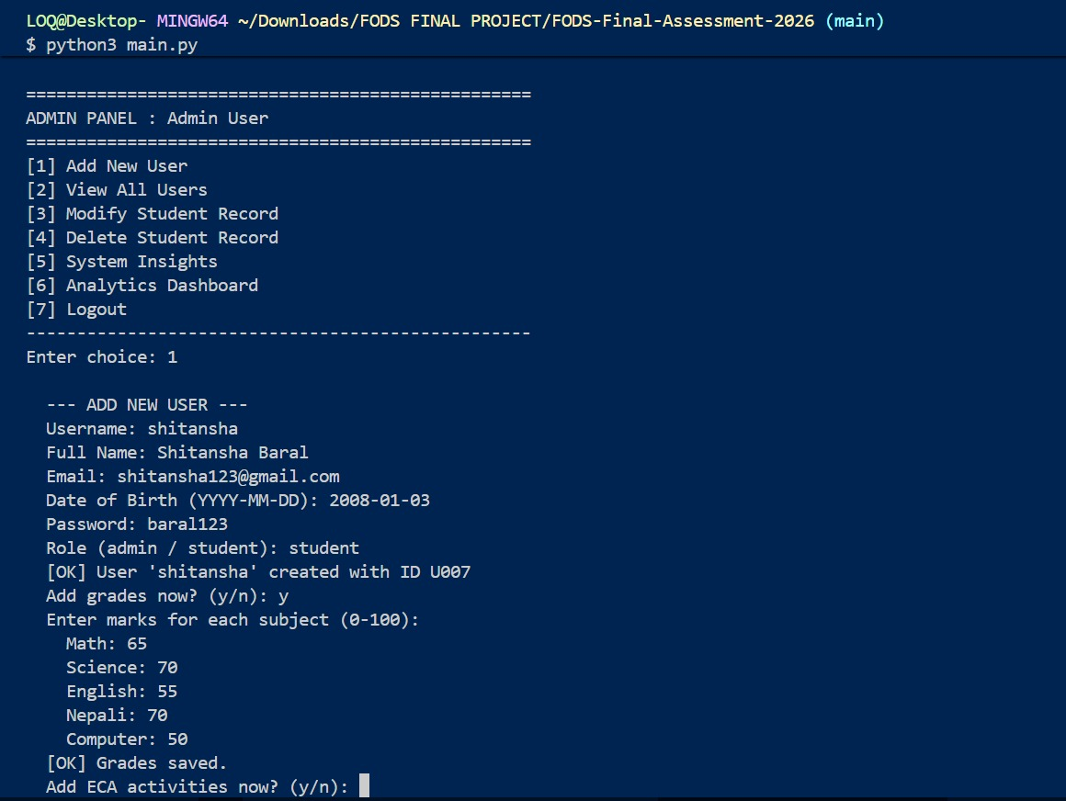

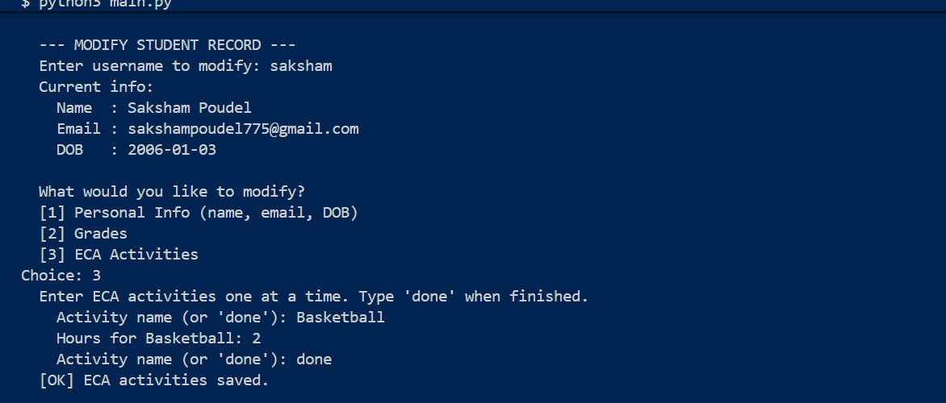

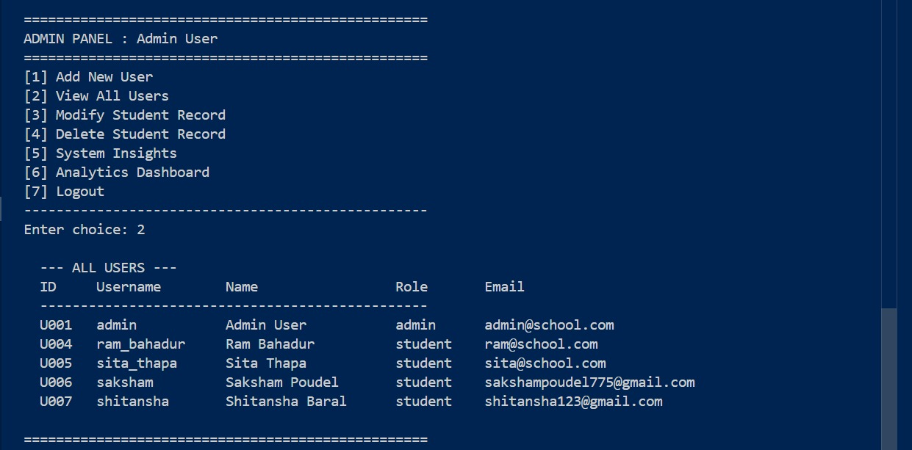

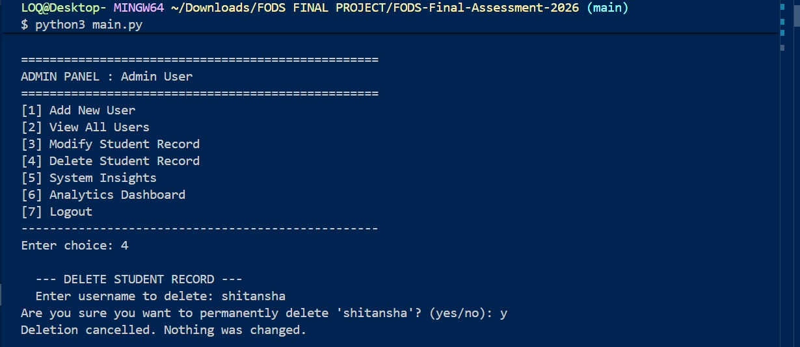

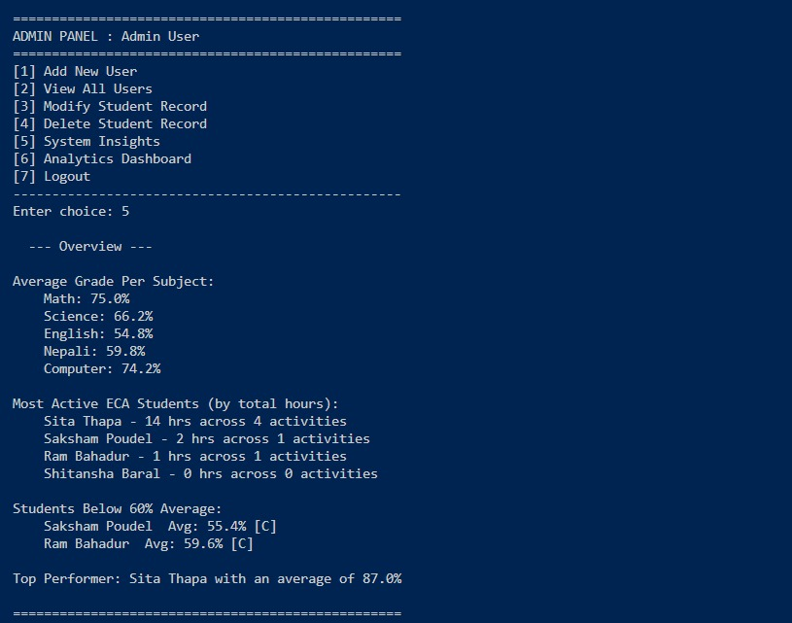

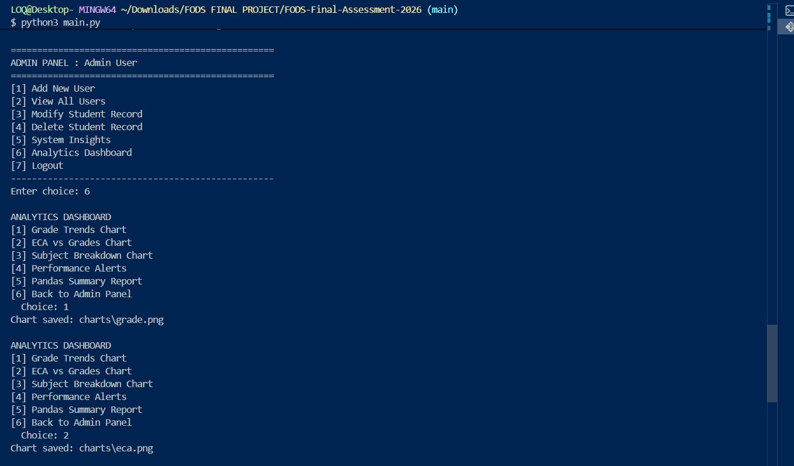

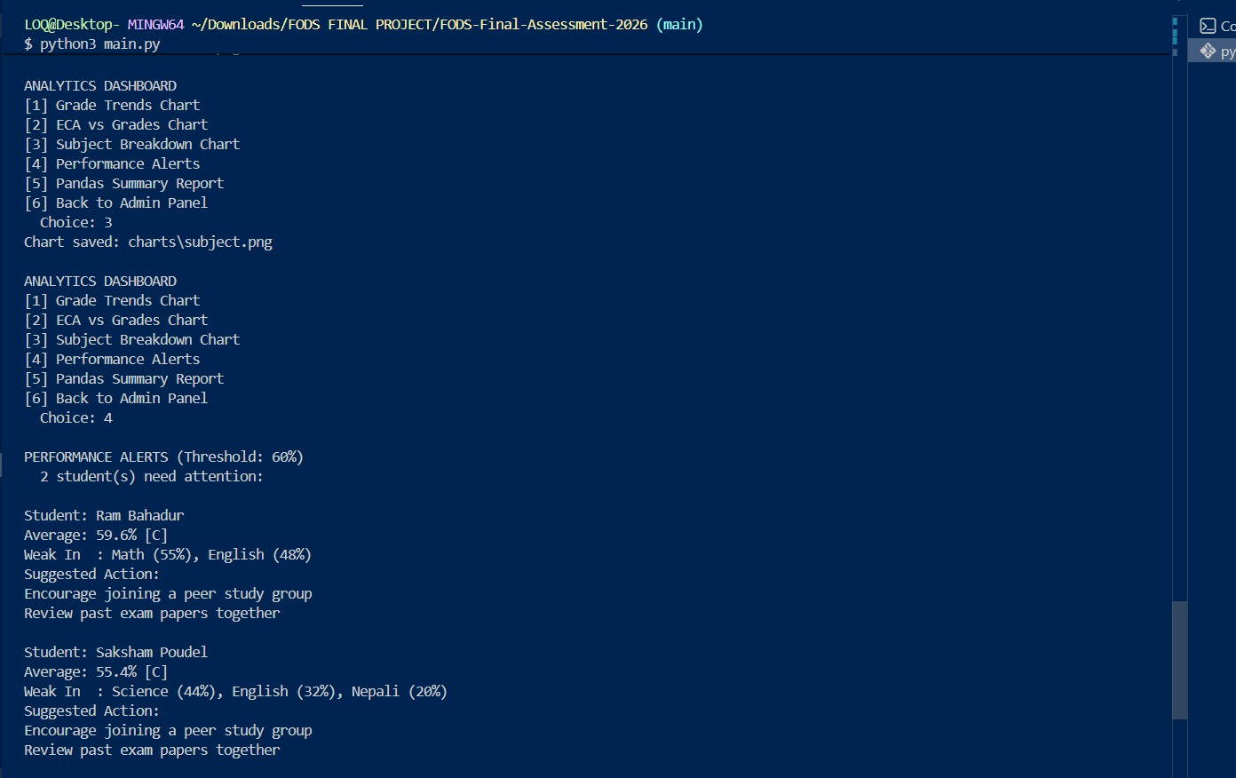

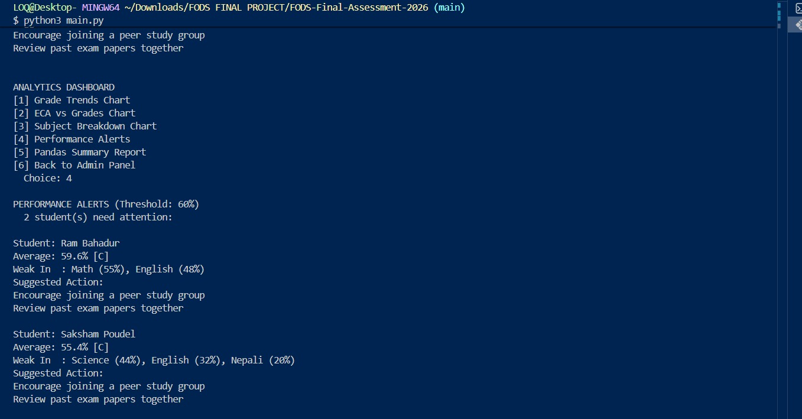

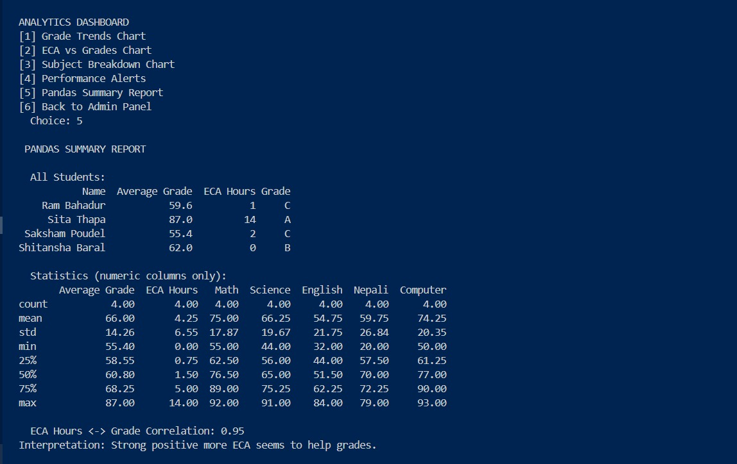

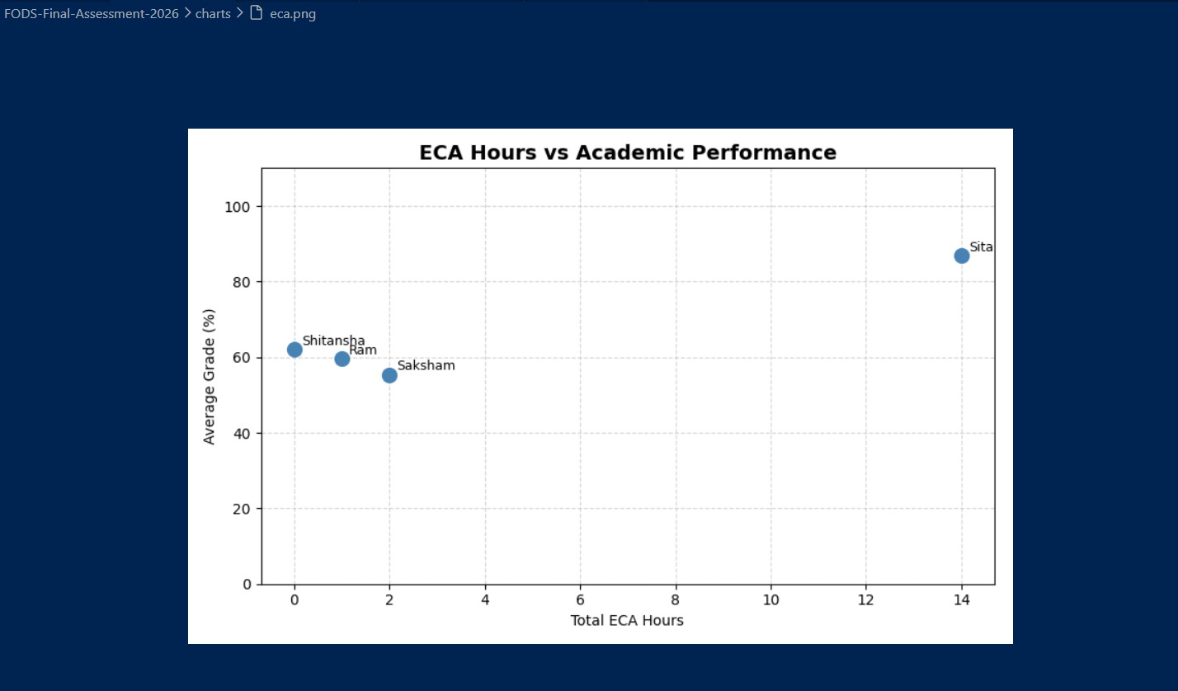

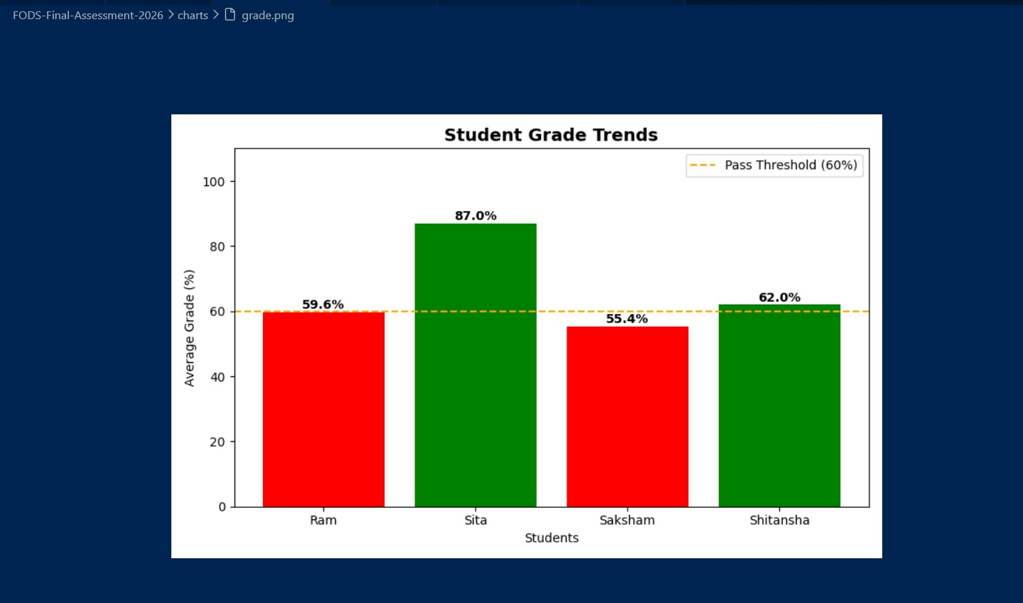

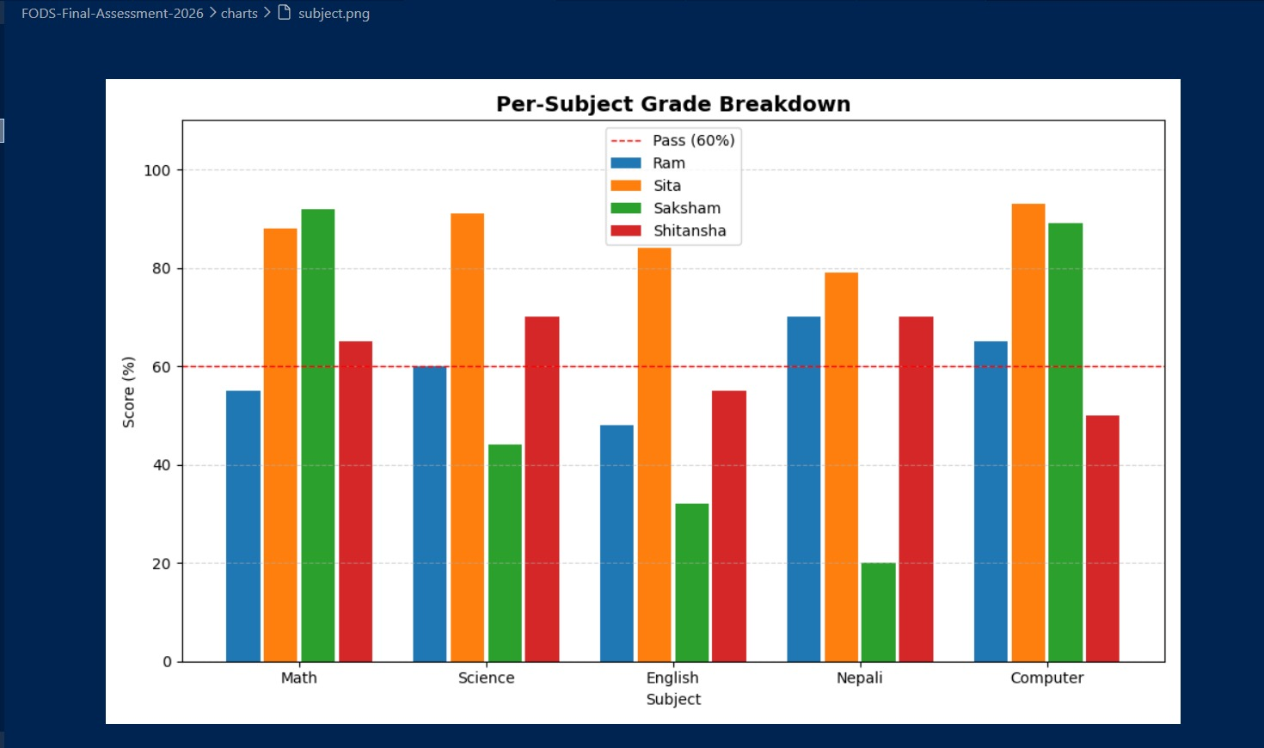

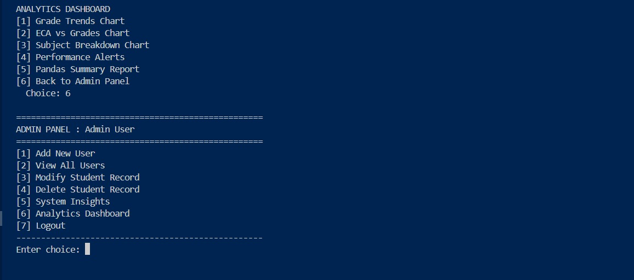

CONCLUSION
The profile management system successfully demonstrates the implementation of a basic role-based application using Python. It highlights important programming concepts such as modular design, authentication, and control flow. While the system is simple, it provides a strong foundation for building more advanced and secure applications in the future.

